Script-Family-Aware Contrastive Adapters (SFA-CA)
for Cross-Lingual and Low-Resource Authorship Attribution of AI-Generated Text
Project Report — Probabilistic Graphical Models / NLP Track
Goli Jyothish | B.Tech AI & Data Science | Amrita Vishwa Vidyapeetham, Andhra Pradesh
Base Paper: La Cava, Macko, Moro, Srba & Tagarelli, "Authorship Attribution in Multilingual Machine-Generated Texts", ACL 2026

Abstract
Large Language Models (LLMs) can now generate fluent, human-like text in dozens of languages, making it increasingly difficult to determine not only whether a text was machine-generated, but specifically which model generated it. The most recent and comprehensive study of this problem — La Cava et al. (ACL 2026), "Authorship Attribution in Multilingual Machine-Generated Texts" — evaluates eight attribution methods across 18 languages, 8 language families, and 5 writing scripts, and demonstrates that both attribution accuracy and cross-lingual transferability collapse once a target language belongs to a script or family unseen during training. The authors explicitly identify two open gaps: extending coverage to low-resource languages, and improving robustness of cross-script transfer.
This project addresses both gaps simultaneously through a single novel contribution: Script-Family-Aware Contrastive Adapters (SFA-CA) — a lightweight, parameter-efficient fine-tuning method that trains a small LoRA (Low-Rank Adaptation) module per script/language-family cluster on top of a frozen multilingual backbone (XLM-RoBERTa-large), optimized with a two-axis contrastive objective that pulls together same-generator representations across families while pushing apart different-generator representations within a family. The method is evaluated on the existing MULTITuDE v3 benchmark and on a newly constructed low-resource-language extension, and compared directly against the base paper's strongest reported baselines (OTBDetector, mdok, XLM-RoBERTa-large, Qwen3-4B-Base). This report documents the problem definition, data pipeline, model design, training strategy, baseline comparisons, and evaluation plan for the project.

1. Problem Definition
This project is built directly on top of two formally defined problems from the base paper, which we then extend with a third problem that constitutes our novel contribution.

1.1 ML-MGT — Multilingual Machine-Generated Text Attribution (base paper, Problem 1)
Given a set of texts X = X_h ∪ X_m, where X_h contains human-written texts and X_m contains machine-generated texts (MGTs) produced by a set of LLM generators M, and where every text is written in a language drawn from a language set L, the task is to learn a mapping function f : X → Y = {y_h} ∪ Y_m, where y_h is the human label and Y_m is the set of per-generator machine labels. In other words: given any text in any of the covered languages, predict whether it was written by a human or, if machine-generated, by which specific LLM.

1.2 CL-MGT — Cross-Lingual Machine-Generated Text Attribution (base paper, Problem 2)
Let L_train ⊆ L be the languages used to train f, and L_test ⊆ L be the languages used to test it. CL-MGT is the special case of ML-MGT where L_train ⊂ L_test — that is, the model is evaluated on languages it never saw during training. This formalizes the cross-lingual transferability question: can an attribution model trained on some languages generalize to genuinely unseen ones?
The base paper's central empirical finding is that while most existing methods can be adapted to the multilingual setting with reasonable in-distribution performance (RQ1), their CL-MGT transferability (RQ2) degrades sharply once the test language belongs to a script or language family dissimilar to anything seen in training — e.g., a model trained only on Latin-script languages performs poorly on Cyrillic, Arabic, or Hanzi text. Critically, none of the eight methods the paper evaluates was designed with this problem in mind — every method is an existing monolingual or general-multilingual technique simply retrained on multilingual data, with no architectural mechanism that explicitly represents script or family structure.

1.3 Our Extension — Script-Family-Aware Attribution (this project)
We define a refinement of CL-MGT that directly targets its failure mode. Let S = {S₁, S₂, …, S_k} be a partition of the language set L into script/language-family clusters (e.g., Latin, Cyrillic, Greek, Arabic, Hanzi, plus new low-resource clusters we introduce). Instead of learning one global mapping f : X → Y shared indiscriminately across all languages, we learn a shared frozen backbone g(·) plus a lightweight adapter function a_i(·) per cluster S_i, such that for a text x belonging to cluster S_i:
f(x) = h( g(x) + a_i(g(x)) )
where h is a shared classification head reused across all clusters. For a test-time language whose cluster was never seen during training, the nearest cluster by script or typological distance is activated instead of falling back to the unmodified shared backbone — the failure mode the base paper documents repeatedly. This formulation makes script/family structure an explicit, trainable part of the architecture, rather than something the model must infer implicitly from data alone.
Problem statement in one sentence: Design and evaluate a parameter-efficient adapter architecture that explicitly encodes script/language-family structure, and test whether doing so recovers cross-lingual transfer performance that today's script-agnostic methods lose — while remaining cheap enough to extend to genuinely low-resource languages the base paper did not cover.

2. Data Collection

2.1 Primary dataset — MULTITuDE v3
We reuse the MULTITuDE v3 dataset (Macko et al., 2023; 2025) exactly as used in the base paper, to guarantee an apples-to-apples comparison against its reported results. Key characteristics:
- 18 languages spanning 8 language families — Germanic, Romance, Slavic-Latin, Slavic-Cyrillic, Hellenic, Uralic, Semitic, Sino-Tibetan — and 5 writing scripts (Latin, Cyrillic, Greek, Arabic, Hanzi).
- 8 author classes: human-written text (sourced from the MassiveSumm news-summarization corpus) plus 7 LLM generators — Mistral-7B-Instruct-v0.2, OPT-IML-Max-30B, v5-Eagle-7B-HF, Vicuna-13B, Llama-2-70B-Chat-HF, Aya-101, and GPT-3.5-Turbo-0125.
- ≈143,000 training samples and ≈43,000 test samples, evenly balanced across the 8 classes and across languages.
- News-domain text: MGTs were generated by prompting each LLM with the original headline of a human-written article, keeping topic and domain aligned across classes.

2.2 New low-resource extension
To target the base paper's explicitly stated language-coverage gap, we construct a small supplementary dataset covering 2–3 additional low-resource languages absent from MULTITuDE — candidates include languages from the Dravidian family (e.g., Telugu or Tamil), Bantu family, or another underrepresented family, chosen based on generation feasibility with available open LLMs. The collection protocol mirrors the base paper's own pipeline for consistency:
- Human-written text: headlines/articles drawn from an open multilingual news-summarization corpus for the target low-resource language(s).
- Machine-generated text: the same headlines are used to prompt a feasible subset of open LLMs (e.g., Aya-101, which already has documented multilingual coverage, plus one or two additional accessible models) to produce comparable generated counterparts.
- Class balance and per-language sample size are matched as closely as possible to MULTITuDE's own selection criteria (≥95% of the target 1,000 train / 300 test samples per generator) so the extension can be evaluated on the same macro-F1 metric without bias from sample-size skew.

2.3 Data sourcing rationale
MULTITuDE was chosen over alternative multilingual MGT resources (M4GT-Bench, RAID, MultiSocial) for the same reason the base paper selects it: it is the only collection offering a consistent set of generators, generation settings, and domain across every language, which is essential for an unbiased cross-lingual transferability study. Introducing a domain mismatch (as M4GT-Bench does, by composing multiple sub-datasets) or an uneven per-language sample count (as MultiSocial does) would confound the script/family effect we are specifically trying to isolate.

3. Preprocessing

3.1 Text-level cleaning
- Strip HTML/markup artifacts and control characters carried over from the news-summarization source corpora.
- Normalize Unicode (NFC normalization) so that visually identical characters across scripts are represented consistently — important given the multi-script nature of the corpus (Latin, Cyrillic, Greek, Arabic, Hanzi).
- De-duplicate near-identical generations (e.g., truncated repeats from decoding failures) per generator/language pair.

3.2 Tokenization
We tokenize with the XLM-RoBERTa-large SentencePiece tokenizer (the backbone's native tokenizer), truncating/padding to a maximum sequence length of 512 tokens, matching the base paper's fine-tuned-encoder setting for direct comparability. This tokenizer's multilingual subword vocabulary is what allows a single frozen backbone to represent all five scripts without script-specific preprocessing.

3.3 Script/family cluster labeling
Every training and test example is tagged with its script/family cluster label (one of: Latin, Cyrillic, Greek, Arabic, Hanzi, plus new clusters introduced by the low-resource extension). This label is metadata only — it never leaks into the text itself — and is used purely to route each example to the correct LoRA adapter during training and to construct contrastive pairs (Section 5.3).

3.4 Class balancing
Following the base paper's own selection criteria, we keep only languages with ≥95% of the target per-generator sample count, preserving the uniform 1/8-human, 7/8-machine class split. For the low-resource extension, where perfectly balanced generation may not always be achievable, we apply class-weighted loss terms during training rather than discarding scarce examples, since discarding would defeat the purpose of a low-resource-focused contribution.

3.5 Train / validation / test split
We follow MULTITuDE's official train/test split for the base 18 languages. From the training portion, we additionally carve out a stratified validation split (by language and generator, ~10% of training data) used exclusively for hyperparameter tuning and overfitting monitoring (Section 4.3) — this validation split is never seen by the adapters during weight updates.

3.6 Contrastive pair construction
For the SFA-CA contrastive objective (Section 5), each training batch is pre-processed into positive pairs (same generator, potentially different script/family clusters) and negative pairs (different generator, same cluster). This pairing is computed on-the-fly per batch from the cluster and generator labels attached during preprocessing, rather than pre-materializing a fixed pair dataset, to preserve batch diversity across epochs.

4. Model Design and Training / Fine-Tuning

4.a Justification of Architecture Choice
The base paper's own diagnosis is that cross-script failure stems from a distributional mismatch between a backbone's pretraining data and non-Latin scripts, and that every evaluated method treats all languages identically at the architecture level — none inserts any mechanism that explicitly represents script or family structure. SFA-CA is designed as a direct architectural answer to that diagnosis:
- Frozen multilingual backbone (XLM-RoBERTa-large): reused unmodified so that its broad, general-purpose multilingual representation is preserved, and so results remain directly comparable to the base paper's own OTBDetector and XLM-RoBERTa-large rows.
- One LoRA adapter per script/family cluster: a small set of trainable low-rank matrices (Hu et al., ICLR 2022) inserted into the backbone's attention layers, one per cluster, so that each script/family gets a lightweight, dedicated transformation rather than sharing one undifferentiated set of weights across typologically unrelated languages.
- Nearest-cluster routing at inference: for a language whose cluster was unseen during training, we activate the closest cluster by script or typological distance instead of silently falling back to the shared backbone alone — replacing an implicit, uncontrolled failure mode with an explicit, testable design decision.
- Shared classification head: a single multi-class head on top of (backbone + active adapter) output keeps the 8-class (7 LLM + human) setup identical to the base paper's, isolating the adapter mechanism as the only architectural variable under test.
This design reuses two established, well-cited techniques — LoRA (Hu et al., 2022) and the adapter-per-language idea from MAD-X (Pfeiffer et al., EMNLP 2020) — but neither has previously been applied to script-family-aware cross-lingual authorship attribution specifically. The novelty is the combination and the domain, not the invention of an entirely new mechanism, which is what makes the contribution both genuine and feasible within a single-semester scope.

4.b Hyperparameter Tuning
The following hyperparameters are planned for systematic tuning via grid or random search on the held-out validation split (Section 3.5), tracking macro-F1 as the selection criterion:
Hyperparameter | Search range | Rationale
LoRA rank (r) | 4, 8, 16, 32 | Controls adapter capacity vs. parameter cost; smaller clusters (fewer languages) likely need smaller r to avoid overfitting.
LoRA α (scaling) | 8, 16, 32 | Standard LoRA practice of tying α to a multiple of r; tuned jointly with r.
Learning rate | 1e-5 – 5e-4 (log-scale) | Adapters train much faster than full fine-tuning; base paper's encoder fine-tuning uses 2e-6, but frozen-backbone adapter training typically needs a higher rate.
Contrastive temperature (τ) | 0.05, 0.1, 0.2, 0.5 | Controls how sharply the contrastive loss separates generator clusters; follows OTBDetector's own tuning range.
Batch size | 32, 64, 128 | Larger batches give more negative pairs per step for the contrastive loss, at the cost of GPU memory.
Number of clusters (k) | 5 (base) → 6–7 (with low-resource extension) | Ablation target: cluster granularity is itself a design choice tested in Experiment 4.
Epochs / early-stop patience | Up to 15 epochs, patience = 3 | Adapters are small and converge quickly; early stopping on validation macro-F1 guards against overfitting each cluster's (relatively small) training slice.

Given single-GPU compute constraints (Section 9 of the base project scope), tuning is performed with 5-fold cross-validation within each cluster for the smaller hyperparameters (τ, batch size) and a coarser random search over LoRA rank/α, following the same style of tuning the base paper itself used for its StatEnsemble MLP classifier.

4.c Overfitting Condition Checking
Because each script/family cluster is trained on a comparatively small slice of the full corpus, overfitting risk is higher per-adapter than for a single model trained on all data jointly. We plan the following concrete checks:
- Train/validation macro-F1 gap monitoring: track both curves per epoch, per cluster; a gap exceeding a pre-registered threshold (e.g., 0.08 macro-F1) triggers early stopping regardless of the patience counter.
- Early stopping on validation macro-F1 with patience = 3 epochs, restoring the best-validation checkpoint rather than the final epoch's weights.
- Weight decay and dropout inside the LoRA modules (standard LoRA dropout, e.g., 0.05–0.1) to regularize the low-rank updates themselves.
- Learning-curve inspection (loss and macro-F1 vs. epoch, plotted per cluster) to visually confirm convergence rather than memorization — flat or rising validation loss alongside falling training loss is treated as a hard stop signal.
- Held-out low-resource sanity check: since low-resource clusters have the least data, we additionally monitor per-class recall on the smallest classes specifically, since class-level overfitting can hide behind an acceptable macro-F1 average.
- Cross-cluster leakage check: verify that no text (or near-duplicate) appears in both a cluster's training split and another cluster's validation/test split, since shared source headlines across languages in MassiveSumm/MULTITuDE make this a realistic risk to control for.

6. Comparison with Other Models (Including Pre-Trained Models)
SFA-CA is evaluated against every method the base paper reports, using its own published results as the reference baseline — this is what makes the comparison direct and numerically grounded rather than self-reported in isolation.

6.1 Baseline methods (from the base paper)
Method | Family | Key idea
Fast-DetectGPT / Binoculars | Statistical, zero-shot | Extract statistical features (perplexity, rank, log-likelihood) and classify with logistic regression; no fine-tuning.
StatEnsemble | Statistical ensemble | Combines 9 statistical features into one MLP classifier.
RoBERTa-large / XLM-RoBERTa-large | Fine-tuned encoder | English-only vs. multilingual pretrained transformer, fully fine-tuned for attribution.
OTBDetector | Contrastive learner | Contrastive fine-tuning of XLM-RoBERTa-large to separate generator representations; strongest lightweight method in the base paper.
mdok / Qwen3-4B-Base | Fine-tuned decoder | QLoRA fine-tuning of a 4B-parameter decoder LLM with a multiclass classification head; strongest overall, but 7× larger than OTBDetector.
SFA-CA (ours) | Script-aware contrastive adapters | Frozen XLM-RoBERTa-large + one LoRA adapter per script/family cluster, trained with a two-axis contrastive loss; explicitly models script/family structure that every baseline above ignores.

6.2 Reported baseline results (reference, from the base paper — not our numbers)
The chart below reproduces the base paper's own Table 2 macro-F1 results (ML-MGT task, averaged across all 18 languages), included here purely as the numeric baseline our method will be measured against once training and evaluation are complete.
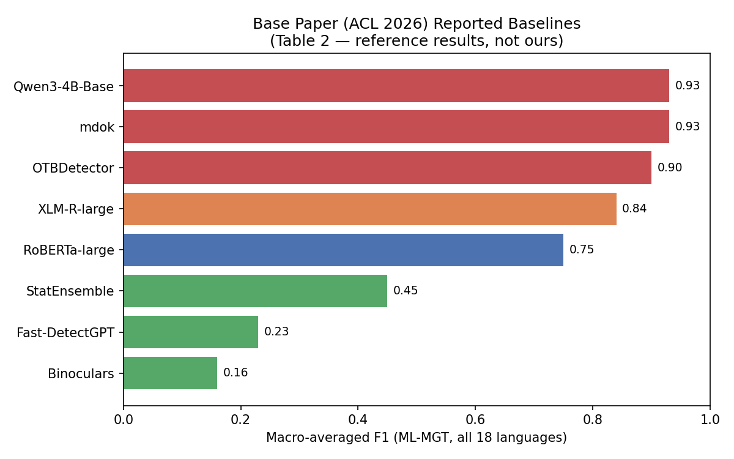
Figure 1. Reported ML-MGT macro-F1 by method, base paper Table 2 (18-language average).
The same base paper (Table 3, RQ2) shows that cross-lingual transfer is strongly training-language dependent, with Russian-trained models generalizing far better than English-trained ones — attributed to Russian's richer inflectional morphology forcing deeper linguistic signal learning rather than superficial token patterns:
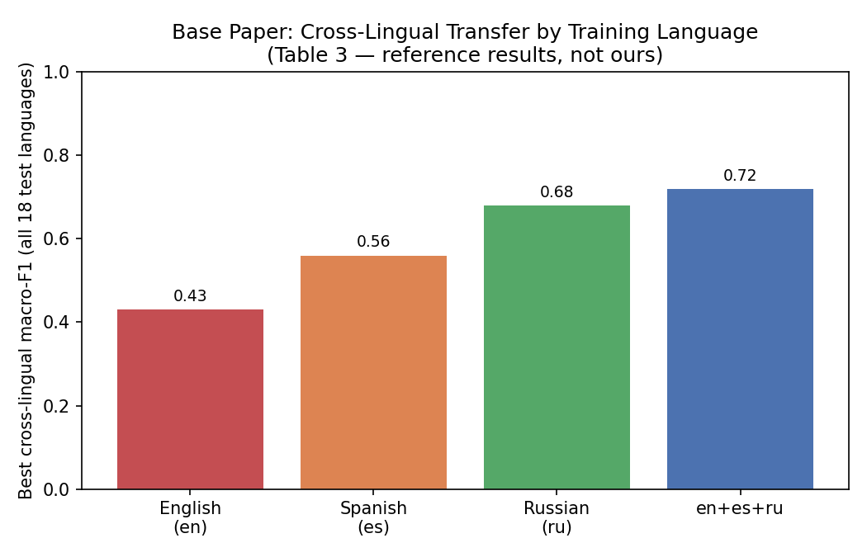
Figure 2. Best cross-lingual macro-F1 by training-language configuration, base paper Table 3 (18-language average).

6.3 Comparison design
Because SFA-CA shares its backbone (XLM-RoBERTa-large) with two of the base paper's own methods (XLM-RoBERTa-large fine-tuned, and OTBDetector), the comparison isolates the adapter mechanism as the primary variable rather than confounding it with a different backbone. Three comparison axes are planned:
- Accuracy axis: macro-F1 on ML-MGT (Experiment 1) and CL-MGT zero-shot transfer (Experiment 2), directly against the base paper's Table 2 and Table 3 numbers for the same backbone.
- Efficiency axis: trainable parameter count and training time, since SFA-CA trains only small LoRA modules per cluster versus full fine-tuning (RoBERTa/XLM-R) or QLoRA fine-tuning of a 4B-parameter model (mdok, Qwen3-4B-Base).
- Ablation axis (Experiment 4): SFA-CA vs. (a) the same frozen backbone with no adapters at all (replicating OTBDetector/XLM-R zero-shot), and (b) a single shared adapter for all languages with no script-family separation — isolating exactly how much benefit comes from the script-family-aware design specifically, rather than from adapters in general.

7. BERT-Based Models for Embedding Generation

7.1 Model choice: XLM-RoBERTa-large
XLM-RoBERTa-large (Conneau et al., 2020) is chosen as the frozen backbone that produces the text embeddings on which every SFA-CA adapter and the shared classification head operate. XLM-RoBERTa is a RoBERTa-family (BERT-derived) masked-language-model encoder pretrained on 2.5TB of CommonCrawl data across 100 languages, making it the natural multilingual counterpart to English-only RoBERTa-large.

7.2 Justification of the model choice
- Direct comparability: the base paper's own OTBDetector — its best-performing lightweight method — is itself built on XLM-RoBERTa-large. Reusing the identical backbone means any performance difference we measure can be attributed to the adapter mechanism itself, not to a different pretrained representation.
- Genuine multilingual, multi-script pretraining coverage: unlike RoBERTa-large (English-only), XLM-RoBERTa-large's subword vocabulary and pretraining corpus already span Latin, Cyrillic, Greek, Arabic, and (to a lesser degree) Hanzi text — exactly the five scripts covered by MULTITuDE — providing a reasonable starting representation for every script/family cluster before any adapter is trained.
- Encoder architecture suits embedding-based classification: as a bidirectional masked-language-model encoder (not an autoregressive decoder like Qwen3-4B-Base), XLM-RoBERTa-large produces a single pooled sequence embedding per input that is naturally suited to a lightweight classification head, without needing the decoder-style generation and QLoRA fine-tuning pipeline that mdok and Qwen3-4B-Base require.
- Feasibility within compute constraints: at ~550M parameters, freezing XLM-RoBERTa-large and training only small LoRA adapters (a few MB per cluster) is realistically trainable on a single consumer/lab GPU within a semester, unlike full QLoRA fine-tuning of a 4B-parameter decoder.
- Proven suitability for the contrastive objective: the training strategy directly extends OTBDetector's own contrastive fine-tuning approach (La Cava & Tagarelli, EMNLP 2025), which was already demonstrated on this exact backbone and confirmed as the best-performing method in the OpenTuringBench benchmark — de-risking the choice of backbone for a contrastive objective specifically.

7.3 How embeddings are generated and used
For each input text x, the frozen backbone produces a pooled sequence embedding g(x) (mean-pooled or [CLS]-pooled final hidden state, consistent with the pooling strategy used by OTBDetector). The active cluster adapter then computes a residual transformation a_i(g(x)), and the combined representation g(x) + a_i(g(x)) is passed to the shared classification head h(·) for the final 8-class prediction. During training, this same combined representation is also the embedding space over which the contrastive loss operates: positive pairs (same generator, any cluster) are pulled together and negative pairs (different generator, same cluster) are pushed apart in this space, directly shaping the geometry of the embeddings — not just the classifier's decision boundary — around generator identity rather than script or language.

8. Evaluation

8.1 Justification of metrics
- Macro-averaged F1 (primary metric): chosen to match the base paper exactly, ensuring every reported number is directly comparable rather than needing re-derivation. Macro-F1 also gives balanced treatment to every class regardless of frequency, which matters here since human-written text is always the minority class (1/8 of samples) against seven pooled LLM classes.
- Per-class (per-generator) F1: reported in addition to the macro average, since the base paper's own RQ3 findings show attribution difficulty is highly generator-dependent (e.g., Llama-2-70B and Vicuna-13B are consistently harder to separate due to their shared underlying architecture). Averaging alone would hide exactly the failure modes SFA-CA is meant to address.
- Confusion matrices, Internal vs. External split: following the base paper's own RQ3 methodology, we report confusion matrices separately for languages seen during training (Internal) and languages held out entirely (External), since this is precisely where cross-script failure is documented to appear.
- Parameter count and training-time overhead: reported alongside accuracy, since SFA-CA's central efficiency claim (small adapters vs. full/QLoRA fine-tuning) is only meaningful if measured explicitly, not inferred from architecture description alone.

8.a Tables and plots to be produced
The following tables and plots are planned once Experiments 1–4 (Section 5.4 of the project design) are run. They mirror the base paper's own presentation style so that placing our results beside theirs is straightforward for a reader.
- Table A — Per-language macro-F1 (ML-MGT, in-cluster): SFA-CA vs. all eight baselines, one column per language, directly extending the base paper's Table 2.
- Table B — Per-language cross-lingual macro-F1 (CL-MGT, zero-shot): SFA-CA vs. baselines, for each training-cluster configuration, extending the base paper's Table 3.
- Table C — Low-resource extension results: in-cluster and cross-cluster macro-F1 on the newly collected low-resource languages, with no equivalent in the base paper.
- Table D — Ablation: full SFA-CA vs. no-adapter backbone vs. single shared adapter (no script-family separation), isolating the source of any improvement.
- Table E — Efficiency comparison: trainable parameters and GPU-hours for SFA-CA vs. each baseline that requires fine-tuning.
- Plot 1 — Bar chart of macro-F1 by method, per script/family cluster (extends Figure 1 of this report with our own results added).
- Plot 2 — Line plot of validation macro-F1 vs. epoch, per cluster, used as the primary overfitting-monitoring artifact described in Section 4.c.
- Plot 3 — Confusion matrices (row-normalized heatmaps), Internal vs. External, for SFA-CA's two or three best-performing configurations, in the same visual style as the base paper's Figure 2.
- Plot 4 — Scatter or bar plot of accuracy gain (SFA-CA − best baseline) vs. script/family distance from the nearest training cluster, to directly test the project's central hypothesis: that explicit script-family structure recovers cross-lingual performance in proportion to how badly the script-agnostic baselines fail.
Note on current status: since this report documents the project's design and methodology ahead of full experimental execution, the tables and plots above are specified in the exact format they will take, using the base paper's own published numbers (Figures 1–2, Section 6.2) as the only concrete results included at this stage. All SFA-CA-specific rows/values will be filled in once training (Section 4, Weeks 5–9 per the project timeline) is complete — no placeholder or fabricated performance numbers for the proposed method are presented here.

9. Report Summary and Conclusion
This project targets a concrete, citable gap left open by a very recent (ACL 2026) top-venue paper: every existing multilingual authorship-attribution method is architecture-agnostic to script and language-family structure, and consequently loses substantial accuracy exactly when transferring across scripts or families — the paper's own central finding. Rather than proposing an unrelated new dataset or an incremental re-run of existing methods, SFA-CA proposes a targeted architectural and training-objective change — script-family-specific LoRA adapters trained with a two-axis contrastive loss — motivated directly by the base paper's own diagnosis of why cross-script transfer fails.
The project is scoped for feasibility within a single academic timeline: the backbone is frozen and reused from an existing strong baseline (OTBDetector's own XLM-RoBERTa-large), the trainable component is deliberately small (LoRA adapters, a few MB each), and the primary dataset is reused as-is from MULTITuDE v3 for direct numeric comparability, with only a modest low-resource extension collected new. Four experiments — in-cluster ML-MGT, zero-shot cross-cluster CL-MGT, a low-resource extension, and an ablation isolating the script-family design specifically — are designed to produce a clean, comparable set of results against the base paper's own published tables.
Expected contributions:
- A novel, lightweight, script-family-aware adapter method for cross-lingual authorship attribution, directly comparable to a strong ACL 2026 baseline.
- Empirical evidence on whether explicit script/family structure in the architecture recovers cross-lingual transfer beyond what a shared multilingual backbone alone achieves.
- A small, original low-resource-language dataset extending MULTITuDE's coverage — directly addressing a gap the base paper's own authors flag as future work.
- A reusable, open training/evaluation codebase that can be extended by future coursework or research.
Key limitations acknowledged: cluster boundaries (how scripts/families are grouped) are a design choice whose sensitivity is only tested via the ablation experiment, not proven optimal a priori; low-resource data quality is bounded by how well available open LLMs already support those languages; compute constraints limit the number of clusters and adapters tested relative to the base paper's full 18-language, 8-family coverage; and, consistent with the base paper itself, adversarial robustness (paraphrasing, obfuscation) is out of scope and left for future work.
Given its direct grounding in a very recent, strong baseline and its targeted, citable motivation, the project is designed with realistic publishability in view — appropriate target venues include the ACL Student Research Workshop, the GenAIDetect or LoResMT workshops, or a regional/IEEE NLP-and-AI conference track, rather than a top-tier main conference on a first submission.

